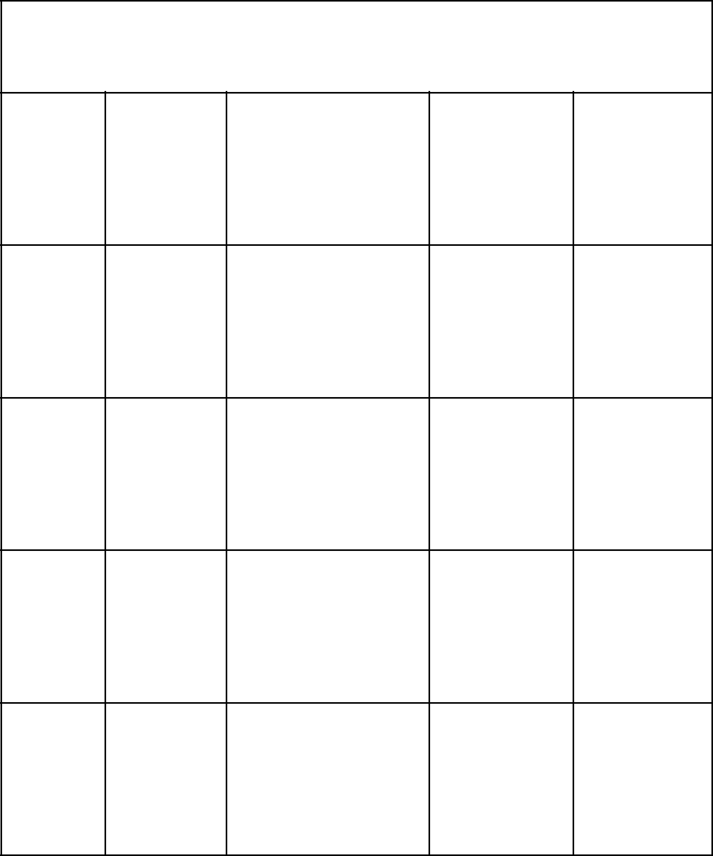**Schechter Experiences Bingo**

|  |  |  |  |  |  |
| --- | --- | --- | --- | --- | --- |
| The | B’nai | Kindergarten | Science | LA |  |
| Giver | Mitzvahs |  |
|  |  |  |  |

|  |  |  |  |  |  |
| --- | --- | --- | --- | --- | --- |
|  | Touching |  |  | Chanukah |  |
| Gidwitz | The | Specials | Imperialism |  |
|  | Lights |  |  | Assembly |  |
|  |  |  |  |  |

|  |  |  |  |  |
| --- | --- | --- | --- | --- |
| Biology Night | **FREE** | 8th Grade | Yom |  |
| **Free Space** | Ha’Zikaron |  |

|  |  |  |  |  |  |
| --- | --- | --- | --- | --- | --- |
| DC Trip | The | schechtermemes1 | Coach | Wrap and |  |
| Outsiders | Doug | Strap |  |

|  |  |  |  |  |
| --- | --- | --- | --- | --- |
| Musical | The Book | Go Lions! | Tikkun | Hebrew |
|  | Thief |  | Ceremony |  |



**Schechter Experiences Bingo**